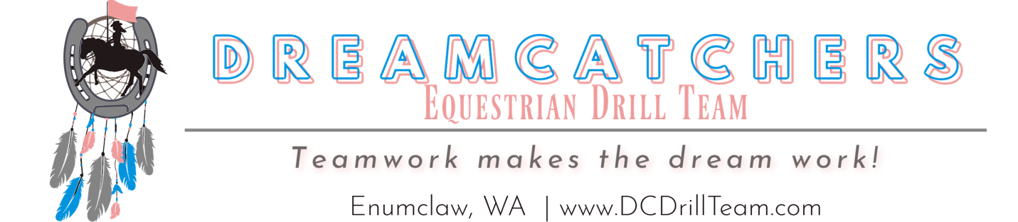

To whom it may concern,

​I am writing to see if you or your company would be interested in sponsoring the DreamCatchers Drill Team. We are a non-profit equestrian drill team out of Enumclaw WA and compete in about five competitions a year, including regionals and state. Our competitions are multiple days, typically Friday-Sunday and take place across Western Washington. We are members of the Washington Ladies Riding Club Association (WLRCA). At competitions, our drill team competes in multiple events such as freestyle, compulsory, short program, Impromptu, and parade.

​The DreamCatchers Drill Team was founded in 2017 when a group of friends decided they wanted to compete in WLRCA. They worked hard to learn the sport of equestrian drill team and develop the skills and teamwork needed to compete in drill. Since then, DreamCatchers has grown to a team of 15 riders, ranging in age from 15-60’s. DreamCatchers is an inclusive, hard-working and diverse team that likes to have fun but also take our competitions seriously.

​We are looking for sponsorships for the upcoming season to help with competition fees and arena rentals.
Thank you for your consideration and here are the options:

Sponsorships of $1,000 or more will receive:
• Flag with Company logo to be flown at competitions and on display for public to see.
• Magnet with Company logo on teams’ trailers.
• Social media advertising on the DreamCatchers page.
• Announcement at each competition
• Signed team picture

Sponsorships of $500 or more will receive:
• Magnet with Company logo on Teams trailers.
• Social media advertising on the DreamCatchers page.
• Announcement at each competition
• Signed team picture

Sponsorships of lesser amounts will still receive:
• Social media advertising on the DreamCatchers page.
• Announcement at each competition
• Signed team picture

Sponsorship Form
Business Name: _______________________________________
Phone Number: _____________________​Email: _____________________________
Mailing Address: __________________________________________________________
City, State, Zip: ___________________________________________________________
Signature: ___________________________________________ Date: ________________

Rider Name: ______________________________________________________________
Payment type:
Check ​​​​ Cash​​ $ _________________ Enclosed
Tax identification number: 85-2974906

Thank you for your sponsorship and support!
Make Checks payable to:
DreamCatchers Drill Team
38235 247th Ave SE Enumclaw, WA 98022
Phone: (206) 300-3035 - Email:taylorshride@yahoo.com

